 |  |  |  |  |  |  |  |  |  |  | ● Date Submitted: |  |  |  |  |  |  |  |  | Enter Date Submitted
SECTION 1 – PROJECT INFORMATION
● Project Type (Check): |  | ☐ Addition ☐ Demo ☐ Driveway-Add/Remove ☒ New Construction ☐ Sidewalk – New/Repair
 |  | ☐ Swimming Pool |  |  |  |  | ☐ Other
● Project Street Address: |  |  | Enter Project Street Address |  |  |  |  |  |  |  |  |  |  |  | ● City/State/Zip: |  |  |  | Enter City/State/Zip
● Project Size (indicate SF or acres): |  |  |  |  | Enter Project Size |  |  | ● Anticipated Start Date: |  |  |  |  |  | Enter Start Date |  | ● Anticipated End Date: |  |  |  |  | Enter End Date
● Approx. Soil Disturbance (indicate SF or acres): |  |  |  |  |  | Enter Soil Disturbance |  |  |  |  | ● # of Storm Drain Inlets within 50 ft. of soil disturbance: |  |  |  |  |  |  |  |  |  |  | Enter # of Storm Drain Inlets
● Does project require other permits or requirements? ☐ Yes ☐ No If yes, check all that apply.
☐ NPDES General Construction Permit (NOI & SWPPP required) |  |  |  |  |  |  |  |  |  | ☐ Dept. of Fish & Game Section 1600 Agreement (Streambed Alteration)
☐ NPDES Industrial General Permit |  |  |  |  |  |  |  |  |  | ☐ Waste Discharge Requirements (non-federal State waters)
☐ MS Phase II Permit (ESCP and/or Post Development Stds) |  |  |  |  |  |  |  |  |  | ☐ Irrigated Lands Regulatory Program (commercial Ag)
☐ U.S. Army Corps 404 Permit (Clean Water Act) |  |  |  |  |  |  |  |  |  | ☐ Low or Limited Threat NPDES Permit (de-watering groundwater)
☐ State Water Board 401 Permit (Water Quality Certification)
SECTION 2 - PROPERTY OWNER INFORMATION |  |  |  |  |  |  |  |  |  |  |  | SECTION 3 - CONTRACTOR INFORMATION
● Name: | Enter Name |  |  |  |  |  |  |  |  |  |  | ● Company Name: |  |  |  |  | Enter Company Name
● Mailing Address: | Enter Mailing Address |  |  |  |  |  |  |  |  |  |  | ● Mailing Address: |  |  |  |  | Enter Mailing Address
● City/State/Zip: | Enter City/State/Zip |  |  |  |  |  |  |  |  |  |  | ● City/State/Zip: |  |  |  |  | Enter City/State/Zip
● E-mail: | Enter E-mail |  |  |  |  |  |  |  |  |  |  | ● E-mail: |  |  |  |  | Enter E-mail
● Phone No.: | Enter Phone No. |  |  |  |  |  |  |  |  |  |  | ● Phone No.: |  |  |  |  | Enter Phone No.
 |  |  |  |  |  |  |  |  |  |  |  | ● Contact Person: |  |  |  |  | Enter Contact Person
SECTION 4 – BEST MANAGEMENT PRACTICES
SECTION 4.1 - RUN-ON CONTROL BMP's. When surface flow of storm water runoff is allowed to pass through disturbed soils at an active construction project it can mobilize sediment and carry it into the municipality’s storm drainage system and into the local receiving waters. This results in deposition of sediment in the municipal drainage system which causes more frequent maintenance and can cause flooding. The sediment is also harmful to the local waterways.
● Does storm water have the potential to run-on to the construction site? |  |  |  |  |  |  |  |  |  |  |  |  | ☐ Yes ☐ No |  |  |  |  | 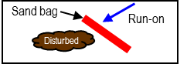
● If yes, will storm water surface flow be diverted around any disturbed soil areas? |  |  |  |  |  |  |  |  |  |  |  |  | ☐ Yes ☐ No
SECTION 4.2 - EROSION CONTROL BMPs. The definition of erosion is the detachment of soil particles. These particles can become detached by rain, wind, or construction activity. Although construction by nature disturbs soil, it is vital to place a temporary or permanent covering over disturbed soil as soon as possible. Projects are not allowed to leave areas of exposed soil that do not have a cover. On the table below and on the site map show how you will prevent erosion at your project.

 |  |  |  | FOR OFFICE USE ONLY
CASQA Fact Sheet | BMP Name | BMP Selected? (Check Box) | Choose the BMP to be implemented from dropdown or insert own description. If not used, state reason why. | Minimum Require-ment (1) | BMP in Plan |  | BMP on
 |  |  |  |  |  |  | Site Map
 |  |  |  |  | Narrative |  | (If no, explain)
 |  |  |  |  | Yes | No | Yes | No
EC-1 | Scheduling (work will be conducted during the dry season) | ☒ | DD/MM/YYYY – DD/MM/YYYY | ✓
EC-2 | Preservation of Existing Vegetation (Existing vegetated areas will not be disturbed) | ☒ | Lawn & Landscaping to be protected | ✓⁽³⁾
EC-4 | Area to be vegetated with landscaping, turf or hydro seeding | ☒ | Damaged Lawn & Landscaping to be replaced | ✓⁽³⁾
EC-7 | Temporary Erosion Control using an erosion control blanket or geotextile | ☒ | Plastic Sheeting as needed | ✓⁽³⁾
EC-6 &  EC-8 | Area covered with a temporary or permanent mulch including straw, wood, compost, hydro mulch, or equivalent | ☒ | In landscaped areas | ✓⁽³⁾
EC-16 | Non-Vegetated Stabilization (covered with aggregate, paving, permanent structures/surfaces) | ☒ | Foundation | ✓⁽³⁾
WE-1 | Wind Erosion Control (kept moist to prevent wind erosion) | ☒ | Water by hose as needed | ✓

SECTION 4.3 - TEMPORARY SEDIMENT CONTROL BMPs. Sediment control is accomplished by two ways. First, giving sediment every opportunity to settle out of storm water runoff while still on the project. Second, remove sediment from surfaces that have been carried or tracked off site before it enters the municipal drains. Each project must have effective perimeter sediment control. Drain inlets within 50 feet of the project must be protected. Any visible track out or sedimentation onto municipal property must be removed as soon as possible. On the table below and on the site map show how you will control sediment at your project.

 |  |  |  | FOR OFFICE USE ONLY
CASQA Fact Sheet | BMP Name | BMP Selected? (Check Box) | Choose the BMP to be implemented from dropdown or insert own description. If not used, state reason why. | Minimum Require-ment (1) | BMP in Plan |  | BMP on
 |  |  |  |  |  |  | Site Map
 |  |  |  |  | Narrative |  | (If no, explain)
 |  |  |  |  | Yes | No | Yes | No
SE-1 | Temporary Silt Fence | ☐ | Not Needed | ✓⁽⁴⁾
SE-2 or  SE-3 | Sediment basin or trap (all or some of the storm water drains to a retention pond or basin where sediment can settle out) | ☐ | Not Needed
SE-5 | Temporary Fiber Rolls/Straw Wattles | ☒ | Around perimeter of addition | ✓⁽⁴⁾
SE-6 or  SE-8 | Temporary Gravel Bag Berm or Sand Bag Barrier | ☒ | At Drain Inlet & around perimeter of addition as needed | ✓⁽⁴⁾
SE-7 | Street Sweeping (inspect roads and sidewalks daily and sweep as necessary) | ☒ | Manual Sweep as needed | ✓
MS4  Standard | Curb cutback (maintain a min. of 4” of elevation difference between the disturbed soil and the top of the existing curb, sidewalk, or paved surface) | ☐ | Not needed | ✓⁽⁴⁾
SE-10 | Temporary Drain Inlet Protection (mandatory for any DI’s within 50 feet of the project) | ☒ | Gravel Bags | ✓
SE-13 | Compost Socks / Biofilter Bags | ☐ | Not Needed
MS4  Standard | Stabilized Construction Exit – Constructed with aggregate at the project owner’s specification, but it must be effective in controlling trackout. | ☐ | Not Needed | ✓
TC-2 | Stabilized Construction Roadways | ☒ | Equipment & Vehicles park on streets
WM-03 | Stockpile Management (stockpiles that have not been actively used in the last 14 days must be covered with an erosion control blanket or plastic sheeting and contained with a fiber roll or gravel bag berm) | ☒ | As needed, not anticipated

SECTION 4.4 - NON-STORM WATER POLLUTION CONTROL BMPs. The City ordinances prohibit the discharge to its municipal drainage system of any wash water, unpermitted construction site dewatering, saw-cutting or grinding slurries, unpermitted hydro test water, chlorinated swimming pool or fountain water, concrete or paint wash out, or spills of hazardous materials or other substances. On the table below, list any of the activities that may apply to your project; and on the site map show the location of these activities.

 |  |  |  | FOR OFFICE USE ONLY
CASQA Fact Sheet | BMP Name | Activity Planned? (Yes/No) | Choose the BMP to be implemented from dropdown or insert own description. If not used, state reason why. | Minimum Require-ment (1) | BMP in Plan |  | BMP on
 |  |  |  |  |  |  | Site Map
 |  |  |  |  | Narrative |  | (If no, explain)
 |  |  |  |  | Yes | No | Yes | No
NS-3 | Paving, Sealing, Saw-cutting, Coring, and Grinding Operations Waste Management | Yes | Waste Cleaned Daily | ✓
NS-7 | Portable Water /Irrigation Testing and Discharge to the Municipal Drainage System | No | N/A | ✓
NS-8 | Vehicle and Equipment Cleaning Waste Management | No | Not allowed on-site | ✓
NS9 &  WM-04 | Vehicle and Equipment Fueling Waste Management | No | Not allowed on-site | ✓
NS-10 | Vehicle and Equipment Maintenance Waste Management | No | Not allowed on-site | ✓
NS-12/13 & WM-08 | Concrete, Stucco, Plaster, Tile, or Masonry Work Waste Management | Yes | Concrete/Plaster wash out boxes to be hauled off | ✓
WM-09 | Temporary Sanitary Waste Facilities (port-a-potties) | Yes | Contained & Secure
WM-01 | Storage of Hazardous Materials on the Project Site (paints, solvents, acids, fuel, lubricants, etc.) | No | All products used are kept on vehicles & taken off site each day | ✓

Footnotes
(1) Not all minimum requirements may be applicable to every project. Applicability to a specific project shall be determined by the QSD.
(2) Use of alternative BMPs must have QSD approval.
(3) Must use at least one of these control measures to establish effective cover of all areas of soil disturbance after 14 days of inactivity.
(4) Must use at least one of these control measures to maintain effective perimeter control where surface water may flow offsite.
The receiving water, the Stanislaus River, is listed on 303d list for sediment and does not have the beneficial uses of Cold, Spawn & Migratory.

SECTION 5 – SITE MAP
A basic site map showing the project boundaries, adjacent streets, storm drain inlets, placement of BMPs, and where construction work will be occurring is required to be included. All BMPs checked and/or activities planned are required to be included on map. Utilize map below or provide own map.

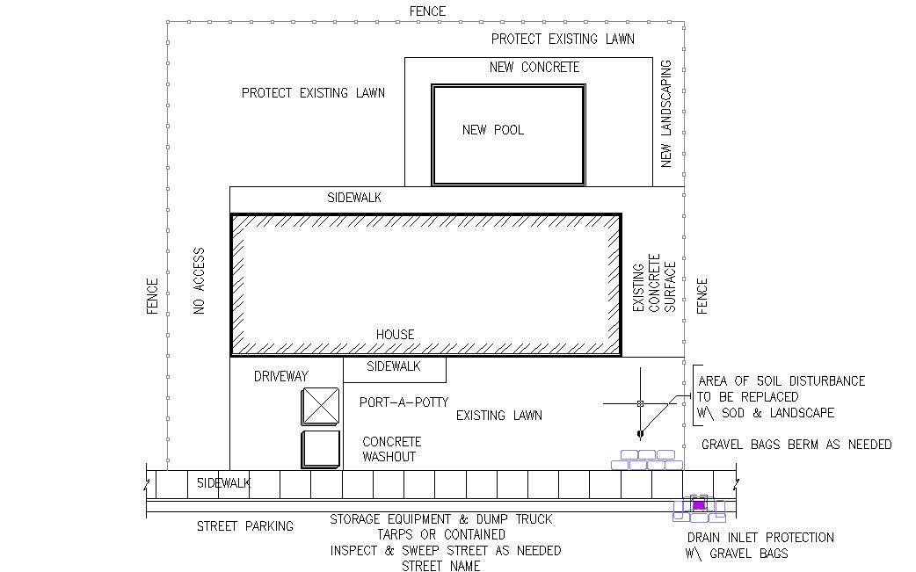
NEW CONSTRUCTION

CALL THE ENGINEERING DEPARTMENT AT (209) 599-2108 AT LEAST 48 HOURS PRIOR TO STARTING ANY WORK
AND FOR EACH INSPECTION REQUEST, INCLUDING FINAL INSPECTION

SECTION 6 – FOR OFFICE USE ONLY

 | PLAN ASSESSMENT |  |  | INSPECTION INFORMATION

1. Check One |  |  |  |  |  |  |  | 1. Pre-Construction Inspection required? ☐ Yes ☐ No
☐ Approved and no changes are needed
☐ Approved with the following MINOR revisions |  |  |  |  |  |  |  | Inspected By |  |  | Date
● |  |  |  |  |  |  |  | 2. Inspection Dates/Notes
●
●
☐ NOT Approved. Requires the following corrections/revisions:
●
●
●
2. Reviewed By:
 |  | Name |  |  | Date
3. Certification: (Check One) |  |  |  |  |  |  |  | 3. Project Completion
☐ QSD No.: |  |  |  |  |  |  |  | All disturbed areas have been stabilized and all temporary erosion
☐ Working under QSD Supervision |  |  |  |  |  |  |  | and sediment control measures that are no longer needed have
Supervising QSD Name/No.: |  |  |  |  |  |  |  | been removed as required by local construction site storm water
4. BP/EP # (if applicable): |  |  |  |  |  |  |  | control ordinance? ☐ Yes ☐ No
IF NOT APPROVED, APPLICANT TO RETURN
CORRECTED ESCP TO ENGINEERING DEPARTMENT
 |  |  |  |  |  |  |  |  | Inspected By |  | Date

Rev. 2024.4

